**The Children’s Bookshop**

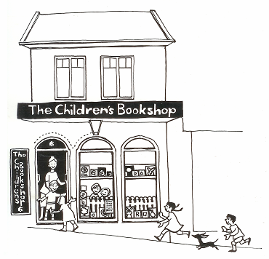

95-97 Cowper Street

Glebe NSW 2037

Phone: (02) 9571 1897

ORDER FORM

**Kate and Jol Temple are visiting your School to celebrate the release of**

**The Underdogs**

**In a city gone to the dogs … get yourself a cat.​​**

**The Underdog Detective Agency has a proud tradition of sniffing out trouble (plus sniffing each other’s butts). They’re on a mission to catch Dogtown’s elusive cat burglar … but if they want to crack this case, they’re going to need help!​​ Jump on the case with Fang and Barkley as they hit the mean streets of Dogtown.**

**Kate and Jol** are internationally award-winning children’s book authors. Kate and Jol live in Sydney, Australia with their two sons. They regularly visit schools and writers’ festivals to talk ideas with young readers and writers. When they’re not writing, Kate pretends to play the piano and Jol makes little egg-carton shelters for his Star Wars characters.

**Students are able to order signed copies of Kate and Jol’s books on the following link:**

<https://www.thechildrensbookshopspeakersagency.com.au/person/temple-kate-speaker/>

**The Children’s Bookshop will deliver the books to your child’s school (free delivery).**

Alternatively, you can call The Children’s Bookshop directly on 9571 1897 to order and pay over the phone.

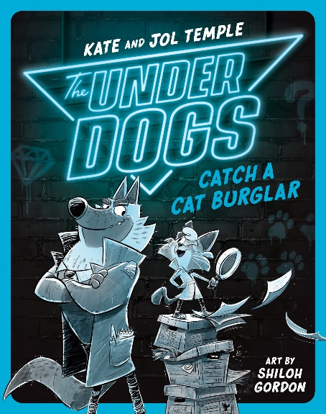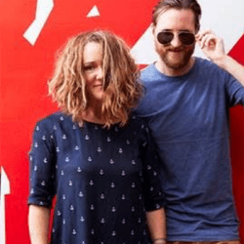

**Please note:** The Children’s Bookshop will endeavor to get books to the school in time for the author/illustrator visit. There are, however, sometimes delays beyond our control and in these cases or in the case of orders within 5 days of the visit the books may arrive after the visit has occurred.

Books will either be signed by the author/illustrator or have a signature sticker from the author/illustrator in the front cover.

Please direct any queries you may have directly to The Children’s Bookshop on 02 9571 11897. Thank you!